MENTAL HEALTH INITIATIVE – RAISING AWARENESS IN CLUBS
The Kerry Health and Wellbeing Committee also organise safeTALK, for Clubs or Distirct Committees, in association with the HSE, who deliver these workshops.
The Kerry Health and Wellbeing Committee partner Jig Saw Kerry who are available to make presentations to clubs, on request.
Information about talks & presentations available to clubs through the Kerry Health and Wellbeing Committe are below. See also www.gaa.ie >Community & Health
Kerry GAA have adopted a Critical Incident Response Plan which is available in a seperate attachment. A club template is also available on this site.
________________________________________________________________

JIG SAW KERRY
At Jigsaw, we understand young people’s mental health. Both online and in our services around the country, we give advice and support to help young people aged 12–25 years-old. If you, or someone you know needs mental health support, we are here for you.
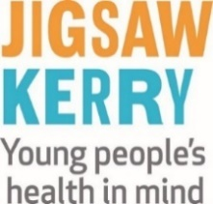
You can call us for free on 1800 544 729, or visit www.jigsaw.ie

Phone: 066 7186785; E mail: kerry@jigsaw.ie

__________________________________________________________________________
One Good Coach: Promoting Young People’s Mental Health
This one hour presentation is aimed at One Good Adults who coach or train young people in a wide variety of sports
As a result of this presentation, participants will:
- Have a greater understanding of mental health
- Have a greater understanding of the importance of their role as One Good Adult
- Have a greater awareness of how to promote and support young people’s mental health in their role as coach
- Learn about their local Jigsaw and how young people can access the service
_________________________________________________________________________________
SOUTHWEST COUNSELLING CENTRE www.southwestcounselling.ie
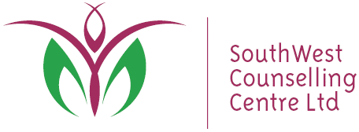
A community based counselling organisation, providing accessible
and affordable Play Therapy and Counselling/Psychotherapy for all ages

Phone: 064 - 6636 416; E mail info@southwestcounselling.ie
--------------------------------------------------------------------------------------------------------------------------------------
THE LITTLE THINGS CAMPAIGN (WWW.YOURMENTALHEALTH.IE)
The GAA and the HSE are working in partnership to bring the messages of protection, resilience and support for mental wellness to local communities. Both organisations are keen to increase their efforts to normalise the conversation around mental health.
The #littlethings campaign highlights that we all experience difficult times in our lives, and that when we do, there are some evidence-based ‘little things’ that can make a big difference to how we feel.
__________________________________________________________________________________

